we added changes to the backend block and made dynamodb table.

Assigned the path of dynamodb and applied terraform init

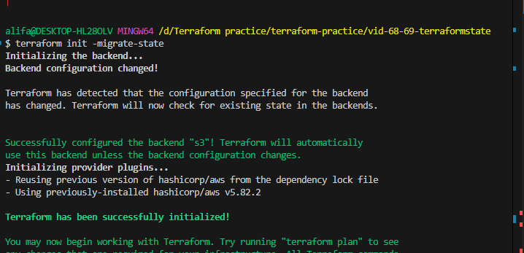

We hate to migrate the state file from s3

Terraform init -migrrate-state

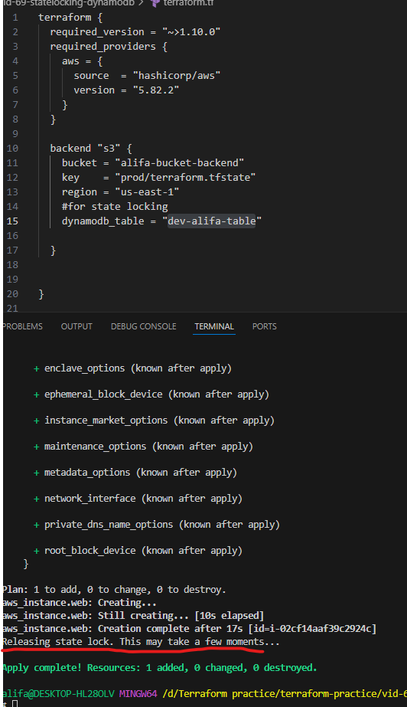

We are using dynamodb as a locking mechanism for terraform state file. When the state file is being written( plan, apply and destroy), the state file will be locked for all other users. This mechanism is useful for avoiding race condition, statefile corruption and conflicts and data loss.

